Continuous Internal Evaluation – 1
- Find all node running:
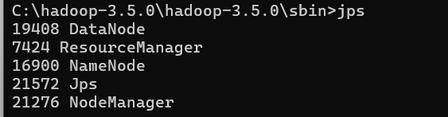

- Store and Access the Dataset Using HDFS
Commands:
hdfs dfs -mkdir -p /bda/movie

hdfs dfs -put "C:\Users\satya\Downloads\movie_ratings_100.csv" /bda/movie/

hdfs dfs -ls /bda/movie
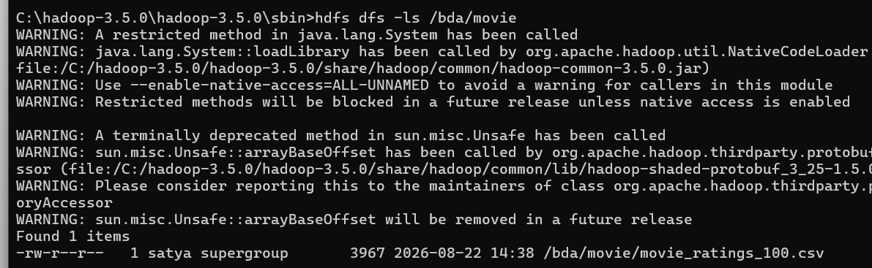

- Implement the Mapper:
Mapper.py
import sys
for line in sys.stdin:
line = line.strip()
# Skip header
if line.startswith("user_id"):
continue
try:
parts = line.split(",")
user_id = parts[0]
movie_id = parts[1]
movie_title = parts[2]
rating = float(parts[3])
print(f"{movie_id}\t{movie_title}\t{rating}")
except:
continue

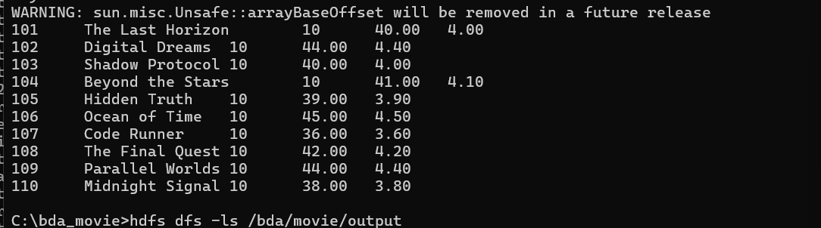

- Perform Distributed Aggregation
Reducer.py
import sys
current_key = None
current_title = None
count = 0
total = 0.0
for line in sys.stdin:
line = line.strip()
if not line:
continue
parts = line.split("\t")
if len(parts) != 2:
continue
key = parts[0]
rating = float(parts[1])
movie_id, movie_title = key.split("|", 1)
if current_key != key:
if current_key is not None:
average = total / count
# Task 4: Minimum 50 ratings
if count >= 50:
print(f"{current_key}\t{current_title}\t{count}\t{total:.2f}\t{average:.2f}")
current_key = key
current_title = movie_title
count = 0
total = 0.0
count += 1
total += rating
# Process last movie
if current_key is not None:
average = total / count
# Task 4: Minimum 50 ratings
if count >= 50:
print(f"{current_key}\t{current_title}\t{count}\t{total:.2f}\t{average:.2f}")

Hadoop MapReduce Execution:
hadoop jar C:\hadoop-3.5.0\hadoop-3.5.0\share\hadoop\tools\lib\hadoop-streaming-3.5.0.jar -files file:///C:/bda_movie/mapper.py -input /bda/movie/movie_ratings_100.csv -output /bda/movie/output -mapper "python mapper.py" -reducer "python reducer.py"
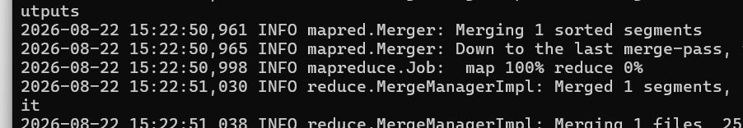

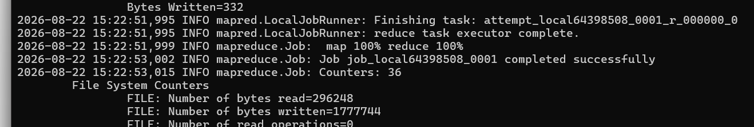

hdfs dfs -cat /bda/movie/output/part-00000
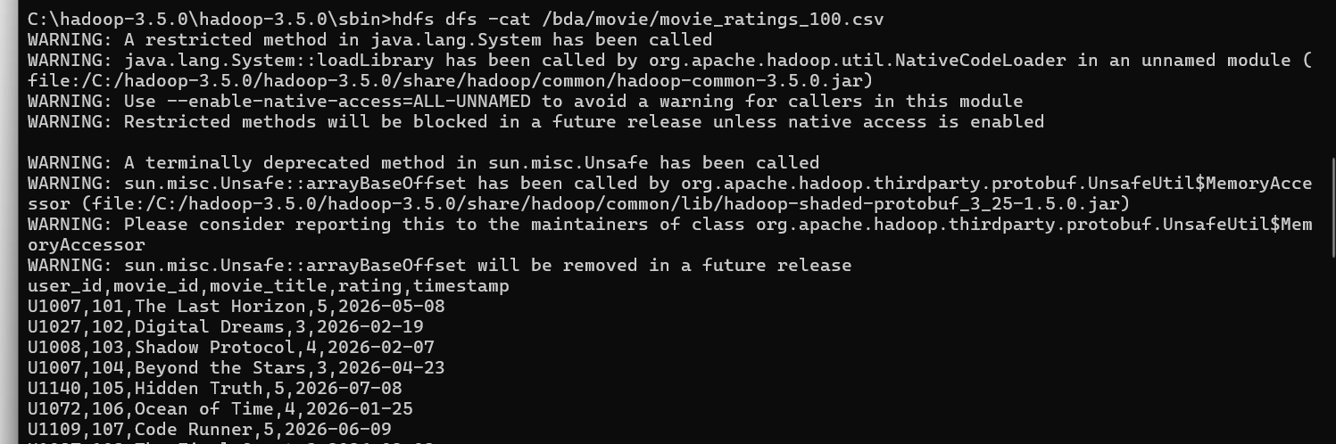

- Apply a Minimum Rating Constraint
Modified reducer.py
Added
if count >= 50:

Output:
No records were produced because no movie has at least 50 ratings in given dataset.

- Generate the Top 10 Movies
Top10.py
import sys
movies = []
for line in sys.stdin:
line = line.strip()
if not line:
continue
parts = line.split("\t")
if len(parts) != 5:
continue
movie_id = parts[0]
movie_title = parts[1]
total_ratings = int(parts[2])
average_rating = float(parts[4])
movies.append((
average_rating,
total_ratings,
movie_id,
movie_title
))
movies.sort(key=lambda x: (-x[0], -x[1]))
for rank, movie in enumerate(movies[:10], 1):
average_rating, total_ratings, movie_id, movie_title = movie
print(
f"{rank}\t{movie_id}\t{movie_title}\t"
f"{average_rating:.2f}\t{total_ratings}"
)

Execution Command:
python top10.py

output: No qualifying movies
Since Task 4 excluded all movies because each movie has fewer than 50 ratings, there are no qualifying movies available for Top-10 ranking.

- Store and Display the Result
Store Output in HDFS:
hdfs dfs -mkdir -p /bda/movie/final_output
hdfs dfs -put final_result.txt /bda/movie/final_output/

Display: hdfs dfs -cat /bda/movie/final_output/final_result.txt
